grep: for extracting single days of data

Revised: 2008-10-29

Problem:
The Crane Wind Data Logger download software produces one data file that contains all of the logged data. Often this file has many days of data, of which only some days are useful.

Solution:
APRS World has developed a small software program that can extract portions of data from one file and save them to another. This allows an operator to select just a year, month, day, hour, or even a single minute of data from the large data file.

Installation:
grep can be downloaded from:
http://www.aprsworld.com/utilities/grep/distribution/
You should save it to a convenient location on your computer.
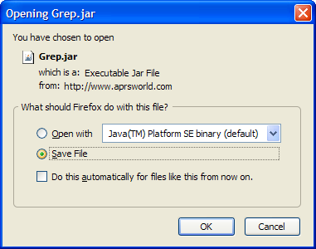
grep requires Java to be installed on your computer. If needed, you can download Java Runtime Environment from:
http://java.sun.com

Use:
1) Open the folder where you saved the Grep.jar file.
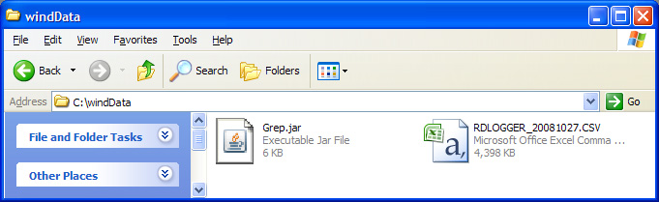
2) Double click on Grep.jar to start the program.
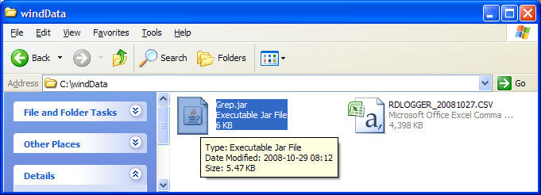
3) You will be presented with the very simple grep main screen.
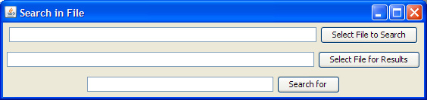

4) Click on the “Select File to Search” button and then select the data file you want to search.
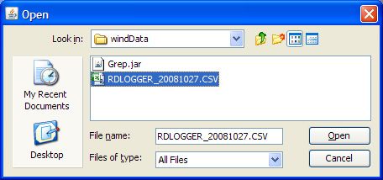
5) The grep main screen will now show the file name of the file to be search. Make sure it is correct and then click on “Select File for Results”. In the dialog you should enter the name of a new file where you want the extracted data to be saved.
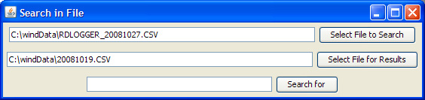
6) Enter the prefix to the date you want to search for, then click “Search for”
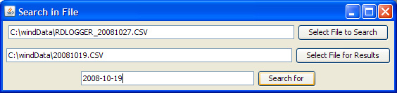
Note: The crane logger download software stores the dates in the format YYYY-MM-DD where YYYY is the year, MM is the month, and DD is the day. January 21st of 2010 would be 2010-01-21. If you want to search by hour you should use the format YYYY-MM-DD HH. For example, 7AM on the December 14th 2008 would be 2008-12-14 07.

7) After a very brief delay, you will see the number of lines of data exported.
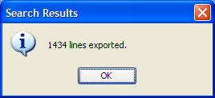
8) The data is exported to the file you chose.
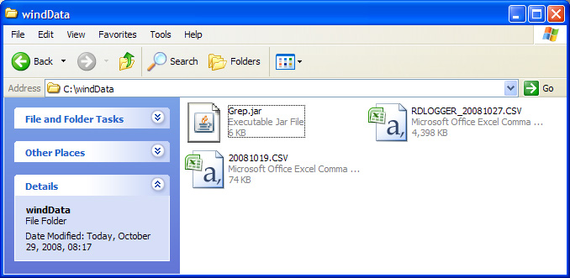
9) You can open this file with your spreadsheet software. It will contain just the date you specify.
